# INTRODUCTION

* 1. Overview

Retail management is the process of running and managing retail outlets' day-to-day activities surrounding the selling of goods and services to customers. Sales for retail management application, retailers can manage their sales, inventory and customer data in one place.

* 1. Purpose

A retail management system (RMS) is a platform that combines several modules to aid in the day-to-day operation of a retail store or chain, such as managing and buying inventory, checking out customers, scheduling employee shifts, keeping track of finances, etc. The POS system in sales force retail management application helps retailers to manage their sales transacations process payments and track inventory levels in realtime.

1. **ProblemDefinition& DesignThinking**
   1. EmpathyMap

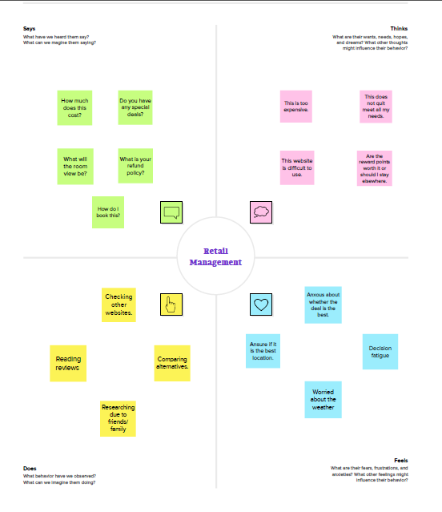

* 1. Ideation&BrainstormingMap

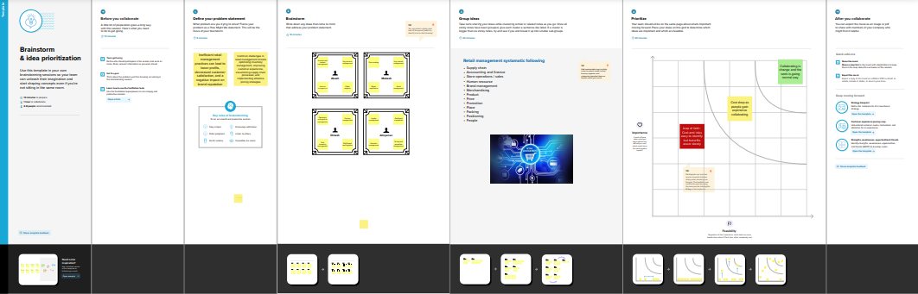

# RESULT

* 1. DataModel:

|  |  |
| --- | --- |
| Fieldlabel | Data type |
| Campaign | text |
| Leads | date |

|  |  |
| --- | --- |
| **App** | **Object** |
| Sales app |  |
| Service app |  |

# Activity&Screenshot

|  |  |
| --- | --- |
| Fieldlabel | Data type |
| Cases |  |
| Acccounts |  |

# 

# 

# TrailheadProfilePublicURL

**Team Leader ;** [**https://trailblazer.me/id/vvivek45**](https://trailblazer.me/id/vvivek45)

**TeamMember1-** [**https://trailblazer.me/id/vini12**](https://trailblazer.me/id/vini12)

# Team Member 2 <https://trailblazer.me/id/rajesh1>

# Team Member 3 <https://trailblazer.me/id/sathi2>

1. **ADVANTAGES**

* **Less capital requirement**
* **More profit margin**
* **Credit facility**
* **Better customer relation**
* **No liability**

**DISADVANTAGES;**

* **High marketing cost**
* **Selling skill required**
* **Very high competition**
* **No economies of buying**
* **It requires proper location**

# APPLICATIONS

* Set up
* Sales
* Service
* Trailhead
* github

# CONCLUSION

# Whether you have a small shop for a big store if you are running a retail business, then retail management is must to run it efficiently.Either you are seller or a cudtomer, everybody has 24 hours in a day and the time is very important for all.

# FUTURESCOPE

# The retail sector in the country is currently booming, providing plenty of career prospects fgor people with a passion for sales marketingplaces, business, diversification, campaigning, ADVERTISING, MARKETTING, RESEARCH and segmentation.

# Overall, Salesforce’s retail managementapplication is a powerful tool for retailers looking to streamline their operations and improve their custoer experience. With its comprehensive features and user-friendly interface, it is an ideal solution for retailsers of all sizes and industries.